***Assignment 1:***

Arjun Patel – FRN006

Q)Convert ferenhit into celcius

*#include*<stdio.h>

*#include*<conio.h>

int main(){

    float F *=* 12;

    printf("%f ferenhit = %f celsius", F, ((F*-*32) *\** 5*/*9));

*// f-32 ** 5/9*

*return* 0;

}

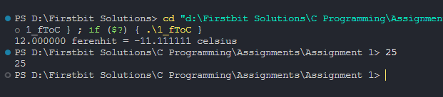

Q)Find Area And perimeter of rectangle and circle

*#include*<stdio.h>

*#include*<conio.h>

int main(){

    int length *=* 10;

    int breath *=* 10;

    printf("Area of rectangle is %d\n", length*\**breath);

    printf("perimeter of rectangle is %d\n", 2 *\** (length*+*breath));

    float radius *=* 5;

    printf("Area of circle is %.2f\n", 3.14 *\** radius *\** radius);

    printf("perimeter of circle is %.2f\n", 2 *\** 3.14 *\** radius);

*return* 0;

}

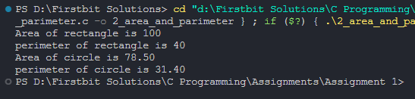

Q)Find sum of digits of number and reverse

*// find sum of 3 digit num and reverse it*

*#include*<stdio.h>

*#include*<conio.h>

int main(){

    int temp *=* 123;

    int num *=* temp;

    int r1 *=* num *%*10; *//3*

    num *=* num */*10; *//12*

    int r2 *=* num *%*10;

    int r3 *=* num */*10;

    printf("Sum of %d is %d\n", temp, r1*+*r2*+*r3);

    printf("Reverse num of %d is %d\n", temp, (r1*\**100)*+*(r2*\**10)*+*r3);

*return* 0;

}

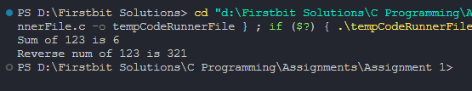

Q)Find Even or Odd

*#include*<stdio.h>

*#include*<conio.h>

int main(){

    int num *=* 25;

    num *%* 2 *?* printf("%d is odd num", num) *:* printf("%d is even num", num);

*return* 0;

}

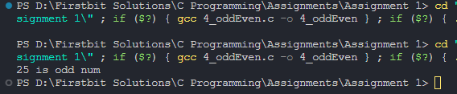

Q)Find Salary after calculating da,ta, hra

*#include*<stdio.h>

*#include*<conio.h>

*// if basic <= 5000 da,ta, hra -> 10%,20,30*

*// otherwise 15,25,30*

int main(){

    float basic *=* 4500;

    float salary;

*if*(basic *<=*5000){

        salary *=* basic *+* (basic *\** 10)*/*100 *+* (basic *\** 20)*/*100 *+* (basic*\**30)*/*100;

    }

*else*

        salary *=* basic *+* (basic *\** 15)*/*100 *+* (basic *\** 25)*/*100 *+* (basic*\**30)*/*100;

    printf("Salary is %.2f\n", salary);

*return* 0;

}

